Physics 9A Section A Discussion Questions: Week 4
Question 1: Hammering a nail
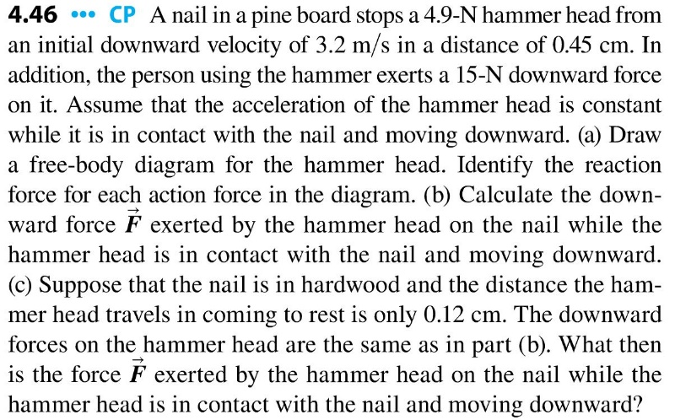
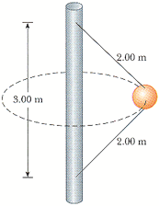
Question 2: Ball swinging in a circle revisited
i: Assume a ball is swinging in a circle, on a rope that is 2m long. If the angle it makes is 40$°$ with respect to the vertical, how long does one revolution take?
ii: Now another identical rope is attached to the ball, as seen in the figure to the right. What is the tension in the lower string, if the ball swings at a constant 7m/s and has a mass of 3.50 kg?
Question 3: Block on an Incline
A 8.00 kg block is on a ramp angled at 40$°$.
i: If the block is stationary, what is the coefficient of static friction between the block and the ramp?
ii: If the block, rather than being stationary, accelerates down the ramp at 1 m/s², what is the coefficient of kinetic friction between the block and the incline?
ii: To accelerate the block at 2 m/s² up the ramp, what horizontal force must be applied? Assume the same coefficient of kinetic friction as in part (ii).
Question 4 (if time is available): Two hanging masses
