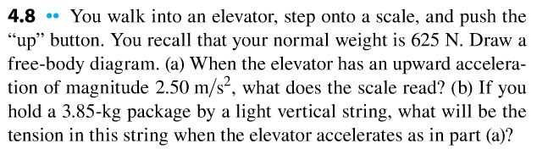
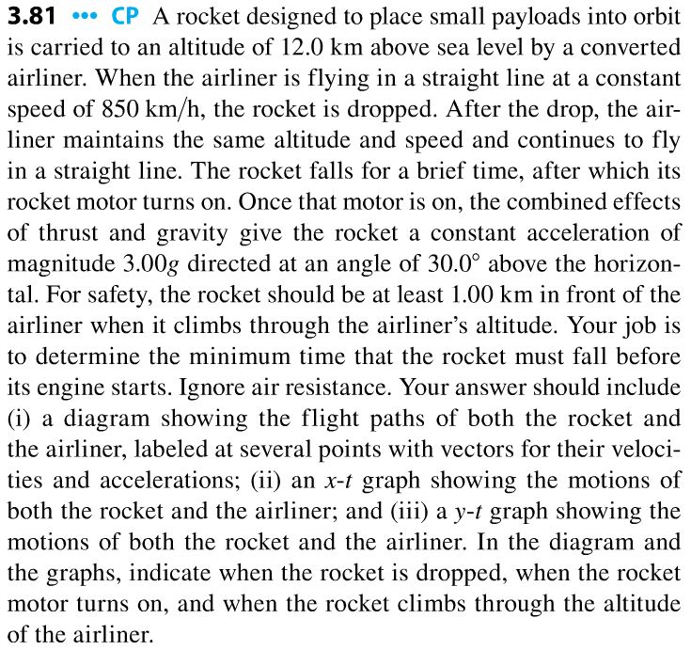
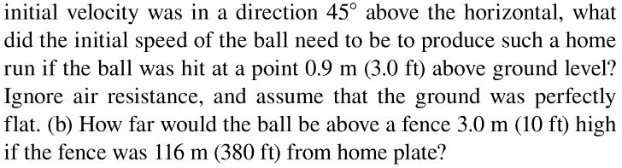
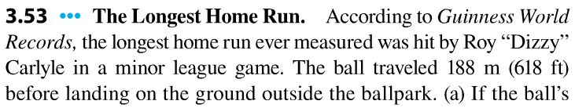
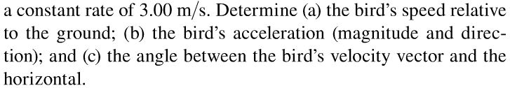
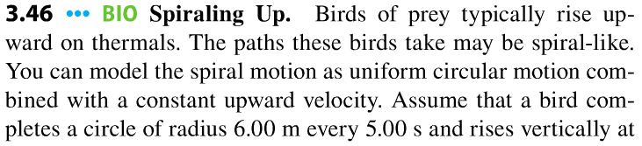
Physics 9A Section A Discussion Questions: Week 2

